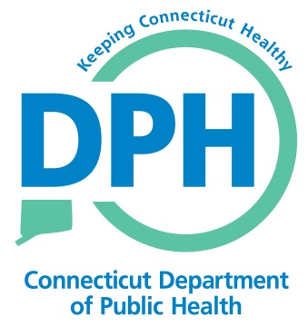
Authorization for Visual and Audio Reproduction
Purpose: To provide authorization for the Connecticut Department of Public Health and its designated agents* for filming, producing, broadcasting, webcasting, and or publishing any words, audio/video tapes, photographs, motion pictures, images, and/or illustrations from the:
CT DPH State Physical Activity Program (SPAN)
Name of Individual (or minor for whom authorizations is given) | Date of Birth (individual or minor)
Address (street/state/zip)

I give my permission to the Connecticut Department of Public Health to make, publish or re-publish the following of me (or of the minor for whom I have custody):

Photographs
Social media
Other ______________________________________________________________

I understand that the above visual and/or audio reproductions are made for the purpose of:

Education
Publicity

I give permission for my name, or the name of the minor for whom I have custody, to be used/published.

Signature of Individual or Legal Guardian | Date

* Designated agents include, but are not limited to, the Centers for Disease Control and Prevention

